Instructions are provided in italics

Welcome to The Ski Run (Heading)

Ski lessons offered: (Sub-heading)
private (bullet)
must be pre-booked (sub bullet)
requires a 10% deposit (sub bullet)
group (bullet)
beginners (sub bullet)
intermediate (sub bullet)
advanced (sub bullet)

This table needs to be created and included in the fact sheet.

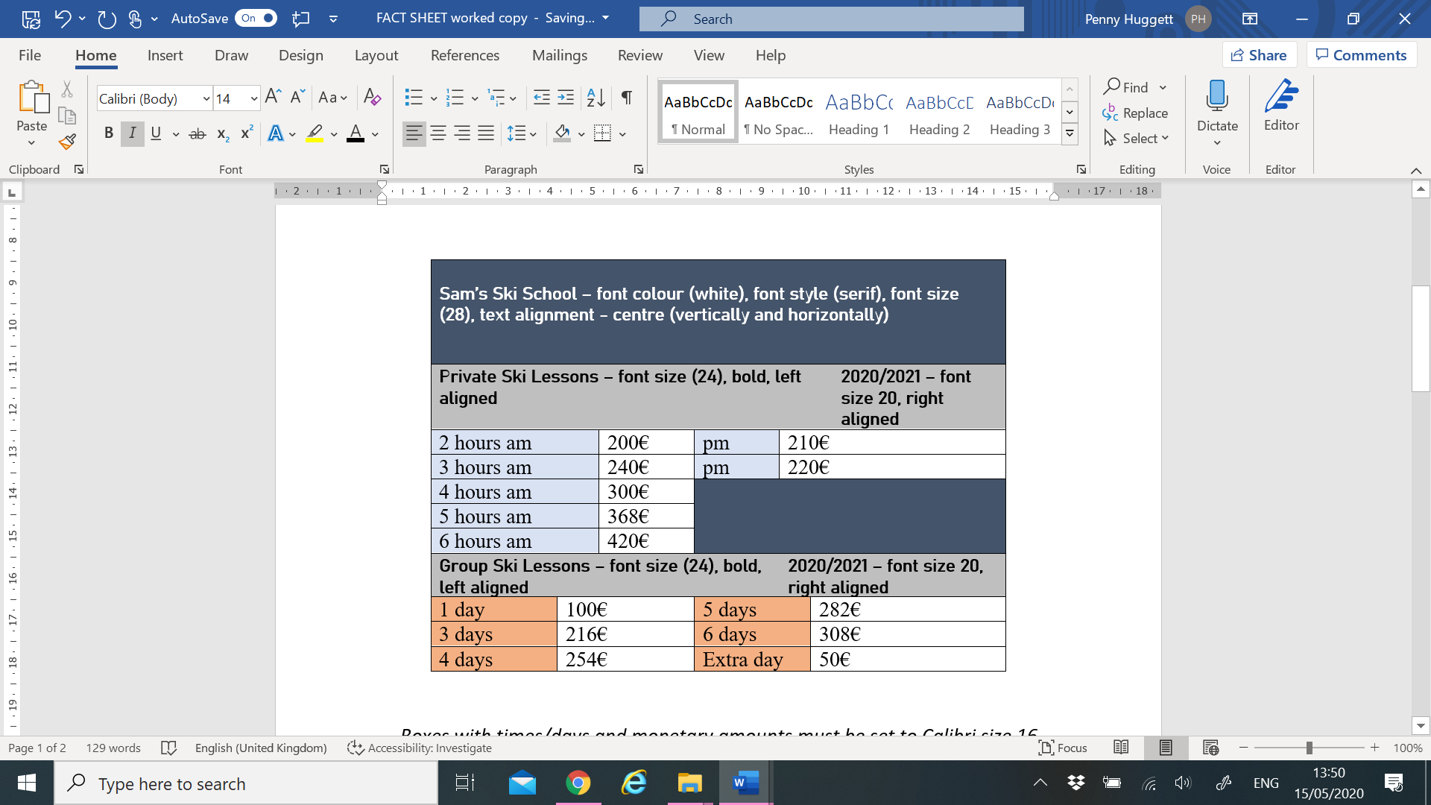

Boxes with times/days and monetary amounts must be set to Calibri size 16

